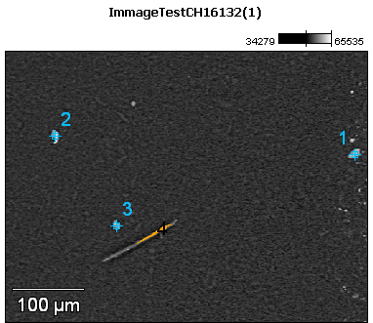

Image Name: ImmageTestCH16132(1)

Image Resolution: 512 by 384

Image Pixel Size: 0.99 µm

Acc. Voltage: 17.0 kV

Magnification: 250

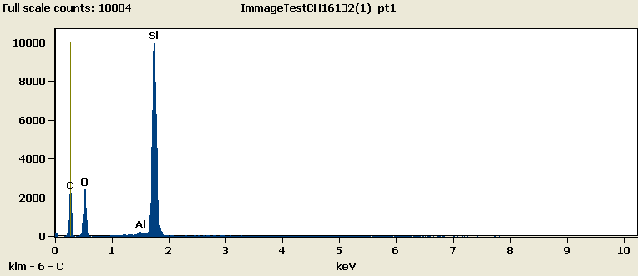

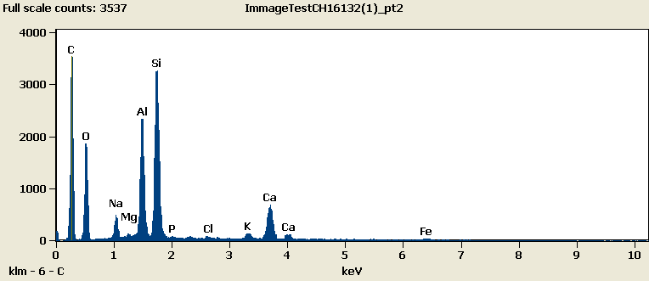

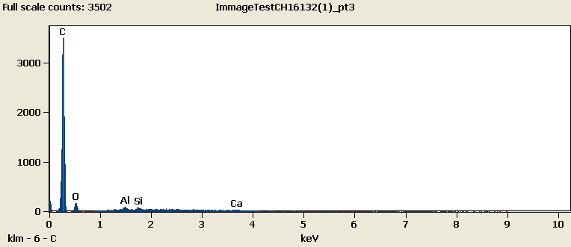

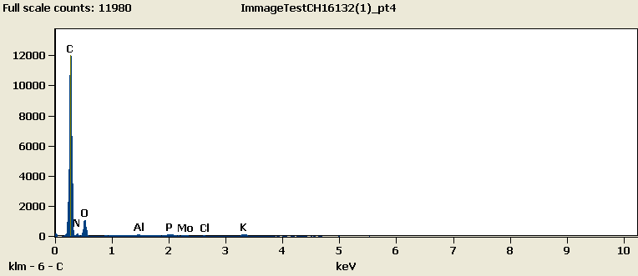

Weight %

|  |  |  |  |  |  |  |  |  |  |  |  |  |  |
| --- | --- | --- | --- | --- | --- | --- | --- | --- | --- | --- | --- | --- | --- |
|  | ***C-K*** | ***N-K*** | ***O-K*** | ***Na-K*** | ***Mg-K*** | ***Al-K*** | ***Si-K*** | ***P-K*** | ***Cl-K*** | ***K-K*** | ***Ca-K*** | ***Fe-K*** | ***Mo-L*** |
| ***ImmageTestCH16132(1)_pt1*** | 48.02 |  | 26.39 |  |  | 0.17 | 25.42 |  |  |  |  |  |  |
| ***ImmageTestCH16132(1)_pt2*** | 51.11 |  | 24.00 | 1.69 | 0.00 | 6.01 | 10.27 | 0.12 | 0.19 | 0.60 | 4.98 | 1.04 |  |
| ***ImmageTestCH16132(1)_pt3*** | 90.26 |  | 7.82 |  |  | 0.67 | 0.55 |  |  |  | 0.69 |  |  |
| ***ImmageTestCH16132(1)_pt4*** | 62.31 | 22.33 | 13.91 |  |  | 0.13 |  | 0.35 | 0.15 | 0.65 |  |  | 0.18 |

Weight % Error (+/- 1 Sigma)

|  |  |  |  |  |  |  |  |  |  |  |  |  |  |
| --- | --- | --- | --- | --- | --- | --- | --- | --- | --- | --- | --- | --- | --- |
|  | ***C-K*** | ***N-K*** | ***O-K*** | ***Na-K*** | ***Mg-K*** | ***Al-K*** | ***Si-K*** | ***P-K*** | ***Cl-K*** | ***K-K*** | ***Ca-K*** | ***Fe-K*** | ***Mo-L*** |
| ***ImmageTestCH16132(1)_pt1*** | ±0.42 |  | ±0.26 |  |  | ±0.02 | ±0.10 |  |  |  |  |  |  |
| ***ImmageTestCH16132(1)_pt2*** | ±1.07 |  | ±0.33 | ±0.06 | ±0.00 | ±0.08 | ±0.10 | ±0.03 | ±0.03 | ±0.07 | ±0.11 | ±0.08 |  |
| ***ImmageTestCH16132(1)_pt3*** | ±0.59 |  | ±0.79 |  |  | ±0.06 | ±0.06 |  |  |  | ±0.11 |  |  |
| ***ImmageTestCH16132(1)_pt4*** | ±0.32 | ±1.49 | ±0.46 |  |  | ±0.01 |  | ±0.03 | ±0.02 | ±0.04 |  |  | ±0.04 |

# Cations

|  |  |  |  |  |  |  |  |  |  |  |  |  |  |
| --- | --- | --- | --- | --- | --- | --- | --- | --- | --- | --- | --- | --- | --- |
|  | ***C-K*** | ***N-K*** | ***O-K*** | ***Na-K*** | ***Mg-K*** | ***Al-K*** | ***Si-K*** | ***P-K*** | ***Cl-K*** | ***K-K*** | ***Ca-K*** | ***Fe-K*** | ***Mo-L*** |
| ***ImmageTestCH16132(1)_pt1*** | 0.00 |  | 0.00 |  |  | 0.00 | 0.00 |  |  |  |  |  |  |
| ***ImmageTestCH16132(1)_pt2*** | 0.00 |  | 0.00 | 0.00 | 0.00 | 0.00 | 0.00 | 0.00 | 0.00 | 0.00 | 0.00 | 0.00 |  |
| ***ImmageTestCH16132(1)_pt3*** | 0.00 |  | 0.00 |  |  | 0.00 | 0.00 |  |  |  | 0.00 |  |  |
| ***ImmageTestCH16132(1)_pt4*** | 0.00 | 0.00 | 0.00 |  |  | 0.00 |  | 0.00 | 0.00 | 0.00 |  |  | 0.00 |